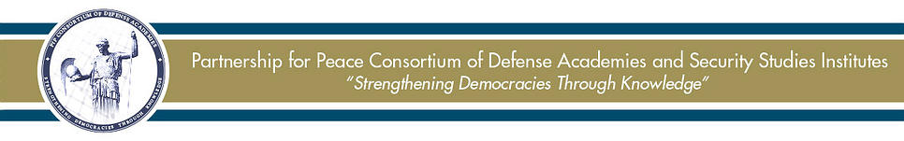
For Immediate Release
PfPC Provides Neutral Forum for South Caucasus Conflict Resolution
GARMISCH-PARTENKIRCHEN, Germany (Nov. 13, 2014) – One of the greatest challenges in conflict resolution is bringing the parties together for constructive dialogue. In this regard, the Partnership for Peace Consortium’s (PfPC) Regional Security in the South Caucasus Study Group (RSSC SG) convened a multinational forum on Austria’s neutral ground, providing a constructive atmosphere for open dialogue.
Hosted by Austria’s National Defense Academy from 6-8 November in Reichenau, Austria, the participants discussed the way forward to break the deadlock in conflicts in the South Caucasus. Prominent conflicts include the territorial disputes between Georgia and the breakaway regions of Abkhazia and South Ossetia, and between Azerbaijan and Armenia over the Nagorno Karabakh region. The discussions benefitted from the diversity of participants, with government and academic representatives from Georgia, Azerbaijan, Armenia, Turkey, Ukraine, and Russia – as well as from disputed territories. The open atmosphere enabled a candid dialogue on the nature of unresolved conflicts in the South Caucasus.
Frederic Labarre, the group’s chairperson, noted that the neutral setting “promoted rapprochement at the working level between conflicting parties.” Openly expressing one another’s grievances and viewpoints, the participants reconsidered status quo negotiation stances, which to date have resulted in deadlock.
The group focused on three central questions: 1) What does the expanding role of the Eurasian Union imply for breakaway regions and the region as a whole? 2) Do the EU and the European Union force “sides” or can both unions play complimentary roles, thereby moving beyond an “east versus west” mindset and towards an “east and west” view? 3) What degree of sovereignty is acceptable for a disputed region to be recognized by the international community? Recent events in Ukraine, including the separation of Crimea and the ongoing crisis in Eastern Ukraine, provided additional contextual relevance for the discussions, as participants compared conflicts in Ukraine to those in the South Caucasus.
Based on the workshop findings, the group will provide recommendations to South Caucasian capitals, OSCE’s Minsk Group, NATO, EU, UN, as well as nations involved in the resolution of the conflicts discussed.
For more information on the PfPC and the RSSC SG, please visit http://www.pfpconsortium.com.
Contact: Brian Huether, +49-8821-750-2256, brian.huether@marshallcenter.org

###

